Name _____________________
AP Language
Rhetorical Analysis Essay
8 February 2019

Objective: The student will write an essay that analyzes the rhetorical choices Zora Neale Hurston used to present a larger argument in the novel Their Eyes Were Watching God.

Step 1: Thesis Statement (Exit Ticket on 8 February 2019)
Develop a thesis statement that prepares a rhetorical analysis essay. Note the features of a rhetorical analysis essay versus a literary analysis essay below.

Literary Analysis Thesis Examples | Rhetorical Analysis Thesis Examples
Through its contrasting river and shore scenes, Twain’s Huckleberry Finn suggests that to find the true expression of American democratic ideals, one must leave “civilized” society and go back to nature. | Mark Twain juxtaposes the river and the shore using specific imagery and word choice within The Adventures of Huckleberry Finn in order to show the reader that the true expression of American ideals is within nature and not “civilized” society.
The imagery in Dylan Thomas’ poem “Fern Hill” reveals the ambiguity of humans’ relationship with nature. | Dylan Thomas uses nostalgic word choice and idyllic imagery to demonstrate to the reader how youth should not be taken for granted in “Fern Hill.”
Through the experience of one man, the Narrative of the Life of Frederick Douglass, An American Slave, accurately depicts the historical record of slave life in its descriptions of the often brutal and quixotic relationship between master and slave and of the fragmentation of slave families. | Frederick Douglass presents a chronological narrative and humanizing anecdotes in order to show the reader that slavery was brutal and inhumane in The Narrative of the Life of Frederick Douglass, An American Slave.
**You can also check out resources in AP Resource packet--pages 11, 23-24.

Step 2: Evidence Mind Mapping (Handwritten by end of class on 12 February 2019)
Complete the evidence mapping for your thesis statement by the end of class. Reference AP Resource Packet (25) to assist in content concept.

Must show:
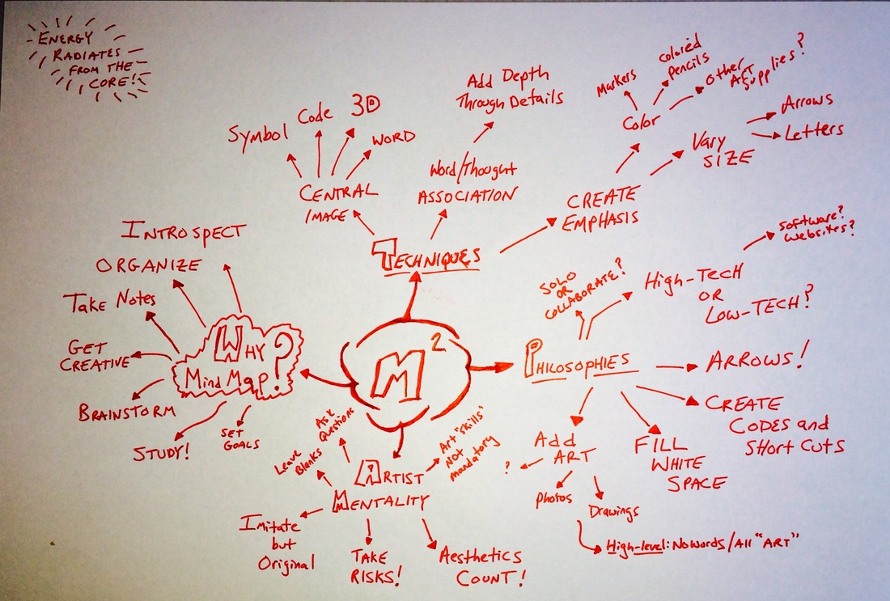
- Selected textual support
- Key analysis words
- Color
- Page numbers

Step 3: Rough Draft (Shared via Google Docs to geri.lear@ekhs.org by 15 February 2019)
Your rough draft will be typed, printed out (in folder), and shared on Google Docs. It must include the following:
- Dynamic and relevant introduction with approved thesis statement at end of the essay.
- MLA Formatting
- Structure (intro, body, conclusion, transitions)
- Textual evidence that is appropriate and convincing
- Parenthetical citations
- Recommended length (i.e. the minimum): 650 words

Step 4: Writing Conference and Revision (Revision will be due within two days of writing conference)
Ms. Lear will meet with you and conduct a conference. Once the conference is completed, you will independently complete a revision, print it out, and put it in your writing folder with the original rough draft.

Reminders:
- Please be sure to refresh your memory from your Gatsby essay on the writing elements you were to improve.
- Read your own draft out loud before printing EVERY TIME.
- Discuss your evidence.
- Avoid phrasing such as “In conclusion,” “This evidence shows,” or other such look at what I am doing statements.
- Plagiarism will result in a zero with no chance for redemption. It is better to try and fail (50% is better than no points and comes with a chance for revision).
- Work days are a gift. Use it or lose it. I will have other assignments running concurrently. No time to waste.

